Freshwater Streamgaging Use Cases
7/29/2026 1:17 PM

Create New Station 3
Update Station Information 5
View Station Information 7
Delete Station 9
Upload Continuous Telemetry Data 11
Upload Continuous Data 14
View Continuous Data 16
QA/Correct Data 18
Export Continuous Data 22
Enter Data Shift Values 24
Enter Field Measurements 26
Develop Rating Curve 29
Develop Rating Shift 31

Notes:

- Hydstra is currently fulfilling their data management needs. Additional functionality that would be nice include an additional data store for finalized data and a more robust option for external users wishing to export/download collected data.

UC-01 | Create New Station | DRAFT

Create a new station within the system.
Details
Parent: Continuous Data Scoping
Primary Actor: Data Administrator | Stakeholders:
Preconditions: User has administrative rights. | Success Guarantee:
Type: | Complexity:
Use Case Status: | Implementation Status:
Assigned To: | Release:

Flow of Events
Main Success Scenario:
- Data Administrator chooses to create a new station
- System displays blank editable ‘Station Information’ fields
- Data Administrator populates ‘Station Information’ fields and submits
- System displays new ‘Station Information’ and requests confirmation
- Data Administrator confirms new ‘Station Information’
- System saves new ‘Station Information’

Extensions:
3a. A required field is missing or invalid
1. System prompts Data Administrator to enter required field or valid data
2. Data Administrator enters missing and/or valid data and submits
3. Continue to Event #4
5a. Data Administrator recognizes a problem with the new ‘Station Information’
1. Data Administrator selects to edit the new ‘Station Information’ further
2. System displays populated editable ‘Station Information’ fields
3. Return to Event #3

Notes | Date Added
Event #4: | 07/25/2008
‘Station Information’ - Station ID, Date established, Type (telemetry, dial-up telemetry, stand-alone stations, staff gage stations, ambient sites, project specific installations), Lat/Long, datum, accuracy, notes, stream class, stream name, river mile,…

UC-02 | Update Station Information | DRAFT

Update an existing station within the system.
Details
Parent: Continuous Data Scoping
Primary Actor: Data Administrator | Stakeholders:
Preconditions: User has update rights on the station of interest. Station already exists within the system. | Success Guarantee:
Type: | Complexity:
Use Case Status: | Implementation Status:
Assigned To: | Release:

Flow of Events
Main Success Scenario:
- Data Administrator chooses to update a ‘Station’s Information’
- System displays editable ‘Station Information’ for a particular station
- Data Administrator makes one or many updates to ‘Station Information’
- System displays summary ‘Station Information’ and requests confirmation
- Data Administrator confirms updated ‘Station Information’
- System saves updated ‘Station Information’

Extensions:
3a. A required field is missing or invalid
1. System prompts Data Administrator to enter required fields or valid data
2. Data Administrator enters the missing and/or valid data and submits
3. Continue to Event #4
5a. Data Administrator recognizes a problem with the updated ‘Station Information’
1. Data Administrator selects to edit the ‘Station Information’ further
2. System displays populated editable ‘Station Information’ fields
3. Return to Event #3

Notes | Date Added

UC-03 | View Station Information | DRAFT

View station information details for an existing station within the system.
Details
Parent: Continuous Data Scoping
Primary Actor: System User | Stakeholders:
Preconditions: User has view/read rights to station information. Station already exists within the system. | Success Guarantee:
Type: | Complexity:
Use Case Status: | Implementation Status:
Assigned To: | Release:

Flow of Events
Main Success Scenario:
- System User chooses to view a specific ‘Station’s Information’
- System displays information for a particular station

Extensions:

Notes | Date Added
Search options need to exist for the user to find the specific station they are interested in. | 08/07/2008

UC-04 | Delete Station | DRAFT

Remove an existing station from the system
Details
Parent: Continuous Data Scoping
Primary Actor: Data Administrator | Stakeholders:
Preconditions: User has update rights to the station of interest. | Success Guarantee:
Type: | Complexity:
Use Case Status: | Implementation Status:
Assigned To: | Release:

Flow of Events
Main Success Scenario:
- Data Administrator chooses to delete a station
- System requests confirmation
- Data Administrator confirms deletion.
- System deletes station

Extensions:
1a. Data are associated with the station being deleted.
- System informs Data Administrator that stations with data associated with them cannot be deleted
- Use Case ends

Notes | Date Added
Not allowed if data are associated with the station | 07/24/2008
Event #1 (Search Options): | 07/24/2008
Search options will need to be in place to allow the user to define what station they are interested in.

UC-05 | Upload Continuous Telemetry Data | DRAFT

Transfer a station’s continuous data back to the system via satellite telemetry
Details
Parent: Continuous Data Scoping
Primary Actor: System Administrator | Stakeholders:
Preconditions: Station is established and code is written so that Hydstra is ready to receive an automatically transferred file. | Success Guarantee:
Type: | Complexity:
Use Case Status: | Implementation Status:
Assigned To: | Release:

Flow of Events
Main Success Scenario:
- Telemetry station sends data packets automatically (at set intervals/windows)
- System receives dataset and saves it to a telemetry data store.

Extensions:

Notes | Date Added
Preconditions: | 07/30/2008
“Import Scenarios” - unique ways of entering data into Hydstra. Telemetry station import, dial-up telemetry station import…
Each station sends a unique station code along with the data packet via “DECODES” and the packet comes out as an .ascii file.
Initial set up for the telemetry stations is the time consuming/user intensive portion. Once set up, this process is done automatically by the system.
Telemetry Data: | 07/30/2008
Telemetry data is not stored long term. Each station that sends telemetry data also has data downloaded physically at the site and the downloaded data is what replaces the telemetry data and gets stored long-term.
System Administrator: | 10/07/2008
The way Hydstra is set up, a single person has the administrative rights to set up these import scenarios.
Types: | 11/20/08
River Stage, Water Temperature, Air Temperature, Conductivity, pH, Dissolved Oxygen

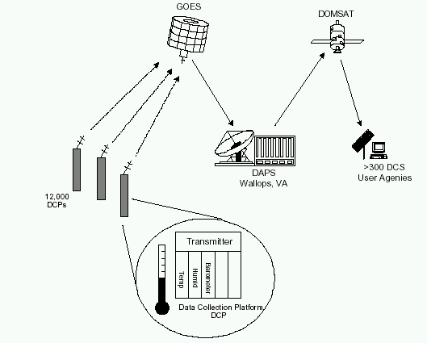

UC-06 | Upload Continuous Data | DRAFT

Upload continuous data files to the system manually.
Details
Parent: Continuous Data Scoping
Primary Actor: Data Administrator | Stakeholders:
Preconditions: User has update rights. Station is set up and is recording continuous data | Success Guarantee:
Type: | Complexity:
Use Case Status: | Implementation Status:
Assigned To: | Release:

Flow of Events
Main Success Scenario:
- Data Administrator uploads continuous data to system.
- System saves continuous data to a raw data storage area

Extensions:

Notes | Date Added
Event #1: | 07/30/2008
Using “Import Scenarios”, manually load continuous data files from telemetry stations, dial-up stations, stand-alone stations...
Water, air, stage, precipitation (some), turbidity (some)

UC-07 | View Continuous Data | DRAFT

View continuous data within the system.
Details
Parent: Continuous Data Scoping
Primary Actor: System User | Stakeholders:
Preconditions: User has read rights. Data exist and are available for viewing | Success Guarantee:
Type: | Complexity:
Use Case Status: | Implementation Status:
Assigned To: | Release:

Flow of Events
Main Success Scenario:
- System User searches for data
- System displays requested data

Extensions:

Notes | Date Added
Event #1: | 07/30/2008
Search options include: Station ID, Date Ranges, Data Quality (from raw, provisional data, final data or all. Options to stipulate what data are retrieved may only be something system administrators or internal system users should be able to do, general external system users may simply receive the most QA’d data possible), parameter(s),…
Search options also include options on how you want the data displayed. Be it graphically, cont. 15 min, calculated daily values, calculated hourly values,… | 07/31/2008
For outside users system is web-based, and pulls data from the working archive data store and the real-time telemetry data store. Maybe it displays raw real-time telemetry data for the past 3 months; the 8 months of data prior to that may be qualified/provisional, and then all data earlier than that may be marked as final. | 07/31/2008

UC-08 | QA/Correct Data | DRAFT

Perform a QA check and corrections to data within the system.
Details
Parent: Continuous Data Scoping
Primary Actor: Data Administrator | Stakeholders:
Preconditions: User has update rights to the data. Data exists within the system. | Success Guarantee:
Type: | Complexity:
Use Case Status: | Implementation Status:
Assigned To: | Release:

Flow of Events
Main Success Scenario:
- Data Administrator chooses to edit certain data
- System displays data and associated QA/correction options
- Data Administrator chooses to make one or many QA/Correction(s) and re-saves the data
- System overwrites edited results in the ‘working data archive’.

Extensions:
3a. A required field is missing or invalid
1. System prompts Data Administrator to enter required fields or valid data
2. Data Administrator enters the missing and/or valid data and submits
3. Continue to Event #4

Notes | Date Added
Event #1: | 07/30/2008
Search options will need to be available for the user to define what data they want to QA/correct.
Event #2: | 07/30/2008
QA/correction options include: data removals/edits, associating quality codes, adding comparative analysis data values, Time weighted data shifts, Rating curves/Rating shifts…
Graphical views of the data will need to be available throughout the QA/correction process. | 07/30/2008
Yearly QA: | 07/31/2008
There is a yearly data QA/correction that happens, when the data changes from being marked provisional, to being marked final.
Portions of the QA process that are automatic within this system: | 07/31/2008
Once the data shifts are entered manually, and once the rating curve/shifts are established, the corrections to the data, based off those two items, are done automatically by the system when either viewing or exporting the data.
Sounds like in the future, there will be a “final” archive, a working archive, then telemetry data. That “final” archive will likely include final stage values, as well as final discharge values. | 08/07/2008

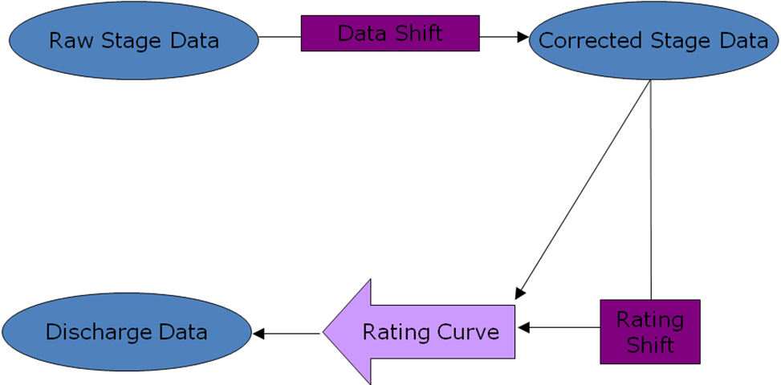

UC-09 | Export Continuous Data | DRAFT

Export continuous data from within the system.
Details
Parent: Continuous Data Scoping
Primary Actor: System User | Stakeholders:
Preconditions: User has rights to export data. Data exists within the system | Success Guarantee:
Type: | Complexity:
Use Case Status: | Implementation Status:
Assigned To: | Release:

Flow of Events
Main Success Scenario:
- System User specifies a particular dataset
- System displays summary data and graphical representation
- System User chooses to export the dataset
- System creates a downloadable file
- System User saves the created file

Extensions:
3a. System User represents an external user
- System User copies/pastes data onto their local hardware
- Use Case ends

Notes | Date Added
Event #1: | 07/30/2008
Search options need to be available for the user to define what data they want to export. Should be able to contain multiple locations worth of data, parameters, time frames, data qualities, etc.
Event #4: | 07/31/2008
Downloadable file should be formatted in a way that is conducive to the user (.csv/.xls). Worksheets for each location, graphs (possibly overlapped with each other if the user desires), parameters…etc. All of which would be nice if the user could pick and choose from.
Currently external users don’t have a way to download a data file export via the web. Instead they are limited to copy/pasting the data they wish to make use of. There is a desire to allow users to export and download the data via the web. | 07/31/2008
Exported data should be able to be in multiple formats; continuous interval, graphically, calculated summary values, etc. | 07/31/2008

UC-10 | Enter Data Shift Values | DRAFT

Manually enter data shift values into the system.
Details
Parent: Continuous Data Scoping
Primary Actor: Data Administrator | Stakeholders:
Preconditions: User has update rights to the data. | Success Guarantee:
Type: | Complexity:
Use Case Status: | Implementation Status:
Assigned To: | Release:

Flow of Events
Main Success Scenario:
- Data Administrator chooses to enter data shift values
- System displays a data table to enter data shift values (and associated metadata)
- Data Administrator populates appropriate fields
- System saves entry

Extensions:
3a. A required field is missing or invalid
1. System prompts Data Administrator to enter required fields or valid data
2. Data Administrator enters the missing and/or valid data and submits
3. Continue to Event #4

Notes | Date Added
(Observed stage – continuous logged stage = Data shift value) Those data shift values then get applied to the continuously logged stage, which then goes on to the rating shift (if there is one), then on to rating curve.
Data table fields: | 07/31/2008
Station, Date, Time, data shift value…

UC-11 | Enter Field Measurements | DRAFT

Enter field measured discharge results to the system.
Details
Parent: Continuous Data Scoping
Primary Actor: Data Administrator | Stakeholders:
Preconditions: User has update rights. Station exists within the system. | Success Guarantee:
Type: | Complexity:
Use Case Status: | Implementation Status:
Assigned To: | Release:

Flow of Events
Main Success Scenario:
- Data Administrator chooses to enter field measurements into the system
- System displays blank data input fields
- Data Administrator populates data input fields
- System saves entered field measurements

Extensions:
1a. Data Administrator chooses to use an ‘import scenario’ to upload electronic field measurements
- Data Administrator imports electronic field measurements using a pre-defined import scenario
- System saves imported field measurements
- Use Case ends
3a. A required field is missing or invalid
1. System prompts Data Administrator to enter required fields or valid data
2. Data Administrator enters the missing and/or valid data and submits
3. Continue to Event #4

Notes | Date Added
Type: | 08/07/2008
We are talking about discharge/velocity measurements taken by field crews while visiting a site for this use case. The two ways of entering measurements is based on what type of device was used to take the measurement. Some of the fancier devices have their own recording functionality that can later be used as to upload data via an import scenario.
There are two ways users can enter field measurements into the system. One is manually enter discharge values (along with a limited amount of additional associated information), the second is to upload data electronically depending on instrument capabilities (that has its own more robust set of additional associated information that gets imported electronically via the import scenario). | 08/07/2008
Date, time, stage, and discharge (and additional associated information) | 08/07/2008
Additional information entered (i.e. data quality, wetted perimeter** (calculated for data that is uploaded, estimated for data that is entered manually), etc.) | 08/07/2008
These values are used for the rating curve, and eventual shift. | 08/07/2008
**Wetted perimeter: is calculated for data that is uploaded, and estimated for data that is entered manually. | 08/07/2008

UC-12 | Develop Rating Curve | DRAFT

Use the analysis tools within the system to develop a rating curve for a station.
Details
Parent: Continuous Data Scoping
Primary Actor: Data Administrator | Stakeholders:
Preconditions: User has update rights. Station has been created. Necessary hydrology work and data collection/calculations have been performed. | Success Guarantee:
Type: | Complexity:
Use Case Status: | Implementation Status:
Assigned To: | Release:

Flow of Events
Main Success Scenario:
- Data Administrator enters a combination of field measurements, continuous stage, and observed stage into the system
- A rating curve is established based on user inputs.
- Data Administrator confirms rating curve
- System saves rating curve.

Extensions:
1a. A required field is missing or invalid
1. System prompts Data Administrator to enter required fields or valid data
2. Data Administrator enters the missing and/or valid data and submits
3. Continue to Event #2

Notes | Date Added
New station. You use the first set of field measurements to establish a rating curve. Field measurements + Stage = rating curve (Plus a lot of work that would be too much detail to go into) | 07/31/2008
This is a onetime process for each station. All rating curves developed after this point will be a product of ratings shifts. | 07/31/2008

UC-13 | Develop Rating Shift | DRAFT

Develop and perform a rating shift.
Details
Parent: Continuous Data Scoping
Primary Actor: Data Administrator | Stakeholders:
Preconditions: User has update rights. Rating curve exists and required data inputs are available. | Success Guarantee:
Type: | Complexity:
Use Case Status: | Implementation Status:
Assigned To: | Release:

Flow of Events
Main Success Scenario:
- Data Administrator chooses to develop a rating shift
- Data Administrator makes use of an internal data analysis package to come up with a rating shift based on additional stage/measurement data and the existing rating curve
- System saves rating shift (which eventually becomes the new rating curve)

Extensions:

Notes | Date Added
The system displays graphically, measurements over time relative to the existing rating curve. It also displays user defined field measurements. These plots are overlaid and the user then determines rating shifts. An internal data analysis package translates those data shifts into a new rating curve. | 08/06/2008
Rating shifts can be developed over a period of time, but usually occur during storm events. | 08/07/2008

UC-01 |  | DRAFT

Details
Parent: Continuous Data Scoping
Primary Actor: | Stakeholders:
Preconditions: | Success Guarantee:
Type: | Complexity:
Use Case Status: | Implementation Status:
Assigned To: | Release:

Flow of Events
Main Success Scenario:

Extensions:

Notes | Date Added

